PROSPECT PLACE
The George Willison Adams Mansion

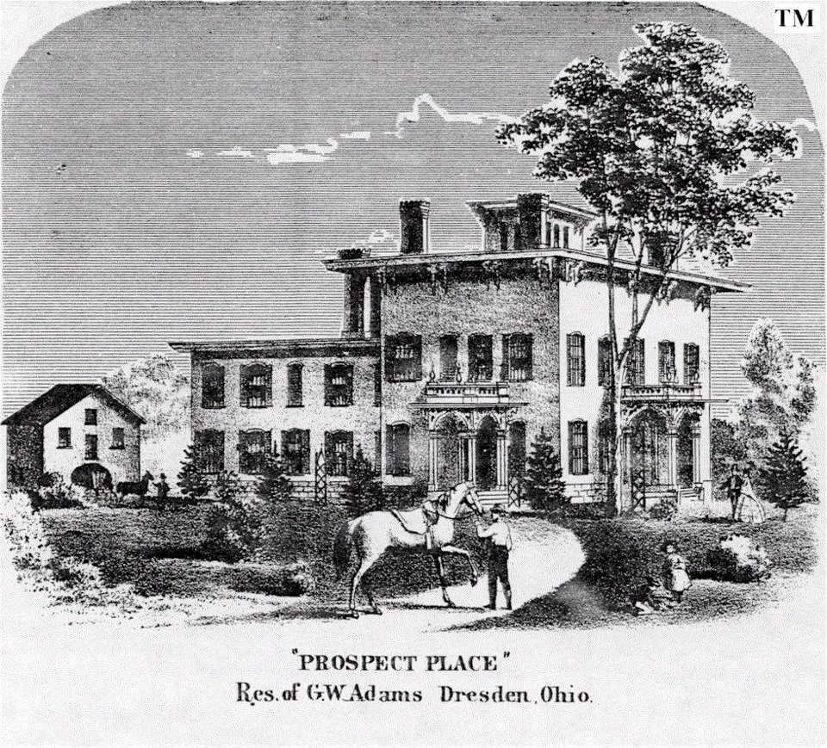

From Virginia to Freedom
The George Adams family came to Ohio in 1808 from Virginia. George Adams’ father, George Beal Adams, was a Virginia plantation owner with over five hundred acres of fertile hill country in both Faquier and Loudon Counties.
When the father of George B. Adams, John, passed away, George, then in his early twenties, inherited the estate and became the head of the plantation. George was uncomfortable with this lifestyle for one reason, slavery: George had served in the Revolutionary War where he was exposed to the idea that all men were created equally. This philosophy was in stark contrast to the slave economy of Virginia and the south. George believed that to hold another man in bondage was a sin against God. George was married and had a family of seven by this time, including George Willison Adams, his youngest.
George made the decision to leave Virginia and start a new life where he would be free from the slave holding curse of his ancestors. He sold the plantation and freed his slaves. The money from the sale of the plantation went to purchase a tract of land in Ohio from a Philadelphia company with holdings in this state. Ohio had recently joined the Union as a State (1803) after being demarcated out of the old “Northwest Territory.” The new State’s lawmakers had ratified their constitution in March, 1803, and within that document Ohio was to be forever free from slavery and involuntary servitude. This echoed an earlier Congressional Law requiring the “Northwest Territory” to be likewise free. The land which George purchased was in that area known as the “Military Grant Lands.” This was a large tract of land in Central Ohio which had been given to Revolutionary War Veterans in payment for their services in that war. The early Congress lacked money with which to pay these men and so “granted” them land in the Ohio Territory as payment. Most of these former soldiers had no interest in going west and settling the frontier and so sold these land tracts to large companies, most of them located in the then U. S. Capitol of Philadelphia. These companies sold the land to pioneers who did want to go west.
One of the most notable of these Revolutionary War Veterans was Jonathan Cass, originally from New Hampshire. He was granted a large tract of land near Dresden and did in fact move here. He built a mansion in the valley very near the area where Prospect Place would later be constructed which he named “River Dale.” This mansion will return to the story at a later point in the possession of another resident of the area.
In addition to purchasing land George also bought all the things needed for the trip west, including wagons and provisions. By the time he was done George was left with little of the money he had in the beginning. The family set out for Ohio in the summer of 1807 and arrived in the spring of 1808. We can only imagine the things they would have experienced on their trip across the Cumberland Road, what we now call U. S. Route 40 or the “National Road.” They were surely challenged with fording many streams and rivers and may have even encountered some not-so-friendly Native Americans. Finally they did reach their “Promised Land” and settled on the eastern side of the Muskingum River near the village of Dresden.
Dresden is an interesting word, its roots are derived from a Slavic word meaning “forest home.” Dresden, Ohio, of that time would most definitely have appeared to spring forth from the middle of the forest. During the 19th century Dresden became a prosperous community of merchants on one of the most important trade routes of the time. The Ohio and Erie Canal was built just north of town in the 1830's and brought to Dresden a market place that reached the far corners of the world. George Willison and his brother Edward Adams were young men when these events were unfolding. In 1826 George Beal Adams, the visionary who sought to free himself and his family from the evil of slave ownership and move west for freedom, died along with his wife Anna Turner Adams. His 150 acres passed to George W. and Edward.
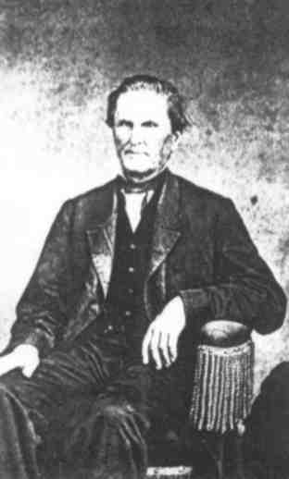
G. W. Adams
The New Business
The young brothers saw an opportunity to capitalize on the new canal. For many years the farmers of northern Muskingum and Coshocton Counties had to take their grain into the city of Zanesville in order for it to be made into flour for sale. George W. and Edward Adams decided that through the sale of their family farm they could raise the money to build a mill on the Muskingum and Coshocton County lines. It would sit on the Ohio-Erie Canal which would provide power for the water wheel, as well as allow for the transportation of the flour directly to ports like New Orleans in the South. In addition to the canal, a “side cut” canal was being dug which would allow the Muskingum River to be directly linked to the canal. This increased the number of ways the Adams brothers had to get their flour to market. The mill was built and became a huge success. George and Edward both married and had families. The brothers built identical homes for a cost of $40,000 each. They were magnificent and large homes. Edward chose a site just behind the mill in the little community called “Adams Mills” which had sprung up around the mill. Today this home is sometimes referred to as the “Prescott Gray House” in honor of a later owner. It stands in Adams Mills to this day and can be seen beside its beautiful red barn on the north side of Ohio Route 16.
(Update : Edward’s home unfortunately burned down on 2.20.19)
George’s house was identical in every way and was built in a field near the canal just north of Trinway. That house was torn down in the late 19th century. George had been very happy there; he had married Clarissa Hopkins Shaff and raised five children in that home. He had also been a member of the Ohio General Assembly while living in that house at the young age of 32. He formed a stock company in order to build a suspension bridge across the Muskingum River at this time. The designer of the bridge was the famous John Augustus Roebling, who later, along with his son, designed the Brooklyn Bridge in New York City. Roebling’s son, Washington, was to serve in the Union Army during the Civil War. His letters home to his father have become a commentary on the events of that time. Later he was to finish the Brooklyn Bridge designed by his father.
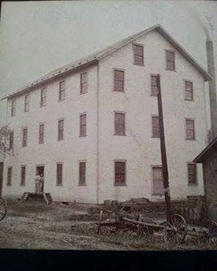 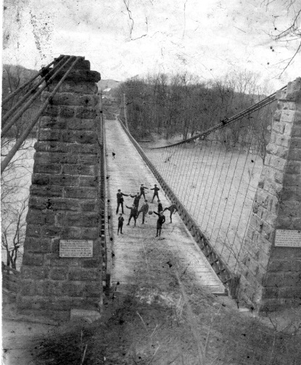
The Adam’s Brothers Mill G.W. Adam’s Suspension Bridge
George Adams knew great joy in his grand farm house and had the admiration of his community. Then tragedy struck in 1853 when his beloved wife of so many years, Clarissa, fell ill and died. The family had previously suffered the loss of an infant in 1852 (George Adams) ,and another one of their sons (Edwards Adams) died a few short weeks after Clarissa.
George was heartbroken and mourned for quite some time. Eventually his depression lifted and he met a young lady named Mary Jane Robinson. She was some twenty years his junior but he loved her as though he were again a youngster himself. He wed Mary and brought her to live with him in the large farm house. Not too much time passed and memories of his first love closed in around him like the walls of the great home. He decided he could no longer live in the house “of bad memories” and would build for his new wife a “fairy tale castle” in which they could live happily ever after.
Construction was quickly completed on a small two story frame house near the Adams Brothers warehouse in Dresden. This little house would serve the family until the mansion was completed.
Prospect Place
The ground was broken for the mansion and hundreds of laborers were hired. The family watched from the little wooden house as a great brick edifice arose from the fields on the knoll to the north.
--------------------------------------------------------------------------
True American Newspaper · Tue, Apr 24, 1855
Burnt – A new house, unfinished, the property of George Adams, near Dresden, Muskingum County was burnt on the 5th instant. Loss $12,000. Twelve hundred dollars in carpenter’s tools were consumed with the building.
---------------------------------------------------------------------------
We believe (as stated in the article above) that the fire likely occurred on April 5th, 1855.
Some people said an elderly Native American woman simply called “Satan” had burned the house because it sat atop the burial place of her people, the Shawnee. The more likely explanation is that of a bricklayer on the project named George Blackburn. He was a notorious character who, when he was not robbing and plundering, worked as a bricklayer in the Dresden area. He supposedly bragged in a drunken stupor to someone in Dresden of having burned the mansion in order to generate more work for himself.
George Blackburn never stood trial for the speculated arson of Prospect Place, and he was serving time in the Ohio State Penitentiary for an unrelated crime while the mansion was being rebuilt. It turns out that Blackburn did have a rather extensive criminal history, and served time for seven convictions at the Ohio State Penitentiary in his lifetime. He also escaped his confinement twice. Blackburn’s criminal history is well documented in the Ohio State Penitentiary archives (housed at the Ohio Historical Center), and also through several period newspapers.
Local legends have since been formed around George Blackburn’s death. However facts support that George Blackburn died at the Ohio State Penitentiary on April 15th, 1896 of heart disease. His remains were handed over to his daughter, and his body was interned at Green Lawn Cemetery.
We highly recommend visiting on our website (and our Blackburn display case) for the full story of George Blackburn.
http://www.gwacenter.org/georgeblackburn
Prospect Place, the name George Adams gave his mansion as it was to be the prospect of a better future, was immediately rebuilt. The second version was identical to the first in every way and stood on the very same foundation. The family lived there for many years and was very happy. Mary gave George two wonderful children in this new home, John Jay and Sophia Adams. George was a great abolitionist like his father before him. He became active in what later became known as the “Underground Railroad” in the 1840's. He became a conductor, going often himself, and later sending his men, to retrieve refugee slaves from the South and bring them to freedom in the North. Originally the mill is said to have been used as the “station”, but as Civil War seemed more likely as the 1850's went along George and Edward decided to move the operation to George's new home. Thus his business would not be endangered and the happenings and operations of the station would be more secret.
The tunnel: Although popular myth of the area maintains that there was an underground tunnel in the basement of Prospect Place, the reality is that the restoration project has yet to discover one. There is a sub-floor pit refrigeration system that could easily be mistaken for a tunnel and could have been used for emergency egress in case of a home invasion by bounty hunters. In the case of the “Underground Railroad” the word underground simply refers to a clandestine activity and does not always denote the presence of an actual tunnel. Although some homes did indeed have tunnels and hidden passages, Prospect Place seems, unfortunately, not to be among them.
It is very likely that many abolitionist meetings took place in the Gentlemen’s Parlor of Prospect Place in the 1850's and 1860's. It is also likely that Mr. Nelson T. Gant may have been a regular guest. Mr. Gant was a former Virginia slave from Loudon County who had been given his freedom on the death of his master. Mr. Gant had moved to Ohio and started an orchard and coal mining operation in Zanesville. From these ventures he became a millionaire and a very important local conductor on the “Underground Railroad.” Another famous abolitionist to be entertained in Prospect Place, although we do not have written evidence, may have been President Abraham Lincoln. Both family stories and local folklore support this.

The Civil War
In 1860 Abraham Lincoln was elected President. Although in his personal sentiment a strong abolitionist, he was politically “sitting on the fence.” He knew that he was an unpopular President and it would take only a little provocation to start the Civil War he feared was coming. There was, in the end, little Abe could do to prevent this, as shortly after his inauguration South Carolina became the first state to secede from the Union thus causing a domino effect until the Southern Confederacy had formed. It is important to note this time in our history as it was America’s defining moment. It was the time in which the crucible of freedom played out its most important act, when the notion that “all men are created equal” was put to the test.
George W. Adams was a great supporter of the Union cause. It is known that he gave a great deal of money to the government during the 1860's. It is rumored that the doors of Prospect Place were open to any Union officer or man in transit in this part of the country and that there may have been plans for the home to become a regional headquarters of the Union Army in the event of a Confederate invasion of Ohio. Luckily Ohio was safe, for the most part, from the Confederacy, but Ohio and Dresden did more than their share to preserve the Union and ensure freedom in America. A trip to Gettysburg, Pennsylvania, or any other Civil War battlefield cemetery will show more than a small number of grave markers proudly displaying “Ohio” as the state of the soldier who departed the field in such honor as death for his country.
The Civil War finally ended after more blood had been spilled on our own soil than could have been believed in 1861. Battle after bloody battle had destroyed the lives of so many Americans both north and south in order to prove America a free nation. In the new age to come the South would be reconstructed and the wounds of our people would start to heal. Never again would one man hold another in fetters in America. Slavery was dead. This did not end the struggle of the African American for civil rights nor did it end bigotry and intolerance but it was a beginning down that road. Some historians say that we still fight the Civil War to this day, with words and ideas instead of guns and cannon.
The celebration in Dresden, mostly paid for by George W. Adams, was said to have lasted for nearly two weeks. The jubilation which this community greeted the end of the war was without equal. The joy over the end of the war was tempered for our community soon thereafter though, as the news of the assassination of Abraham Lincoln reached Ohio. This tragedy saddened a nation which was left to take solace in Mr. Lincoln’s words written after Gettysburg, “that the dead should not have died in vain, that the nation shall, under God, have a new birth of freedom, and that the government of the people, by the people, and for the people, shall not perish from the earth.

The Post War Era
For the Adams family the years after the war were good. Anna, the eldest daughter, married William Cox, Jr., a young man from the River Dale mansion next door. River Dale was originally built by Jonathan Cass, a Revolutionary War veteran from New Hampshire and had been sold to the William Cox family in the early 19th century. William Cox, Sr., was an Irish born English Army officer who had given up his commission in order to move to the United States for freedom and opportunity.
George became involved the last years of his life in the railroad industry. He became the director of the Steubenville and Indiana Railroad and was both the owner and director of the Cincinnati and Muskingum Valley Railroad until his death on August 31, 1879.
After the death of George W. Adams his 14 million dollar estate was divided among his family. His wife Mary received seven million dollars and moved to Zanesville (where she was from). She lived in the Italianate home which currently houses the “Baker Reality Company” (1146 Maple Avenue). The youngest son, John, moved with his mother. The remaining seven million dollars was divided equally among the children, each receiving one million dollars. Prospect Place was inherited by Anna and William Cox. Sophia, another sister, lived for a time in the home with her sister Anna.

The Mystery
William Cox spent a great deal of money on Prospect Place in 1886. He installed a new floor in the main hall and replaced the thirty year old copper barn roof with a slate roof (slate being very popular at the time), 1886 being written into the slate. At some time around the turn of the century there was a grand ball at the estate. It was a reception for a new Episcopal Bishop. There were more than two hundred people in attendance from all over the state. This was the first time ice cream was served in Muskingum County, having been brought in on a specially refrigerated train car. Life continued at the house for some time and all was well. Then around the turn of the century a terrible thing happened. The following is an excerpt from a local paper of the time:
'IS WILL COX DEAD?
That is the question agitating the public today - or if not dead what has become of him?
The mysterious disappearance of Mr. William E. Cox, whose country residence, Prospect Place, located between Dresden and Trinway is the most palatial in the county, has been the theme of conversation in this community for the past week. While it was known last week that he had disappeared and no trace of him could be found, although a detective had been put on his trail, yet it was hoped and thought he would turn up and through respect for the feelings of his family and connections this paper refrained from mentioning the matter in any respect. But Mr. Cox is gone as completely as if the very earth had opened up and swallowed him and in spite of every effort made to get some trace of him by his family, his legal advisors and his friends none can be had.
Mr. Cox left home on Friday, November 15, just before noon, informing his family that he was going to Zanesville on business, and that as he was in a hurry he would not stop for dinner. When he arrived at Trinway he spoke to Henry Park and said he wished he had someone to do an errand for him in Zanesville as he had some business in Columbus and it would put him out very much if he did not go to attend to it. Mr. Park said his wife was on the C & M.V. train which would soon start for Zanesville, and she could attend to Mr. Cox's errand, and the latter gentleman gave Mr. Park $255, and told him to have Mrs. Park pay it to A. E. Starr & Co., on his (Cox's) account. He then took the Panhandle train for Columbus.....
In another article later...
W. E. COX LOCATED
Seen on the streets of San Francisco by Miss Jennie Adams, who formerly resided here.
Mrs. W.E. Cox has received a letter from Jennie Adams, daughter of the late Samuel Adams and who was born and for the greater part of her life resided in Dresden, in which she states that she met Mr. Cox a few days ago upon the streets of San Francisco, California, in company with a strange gentleman. Having been absent from Dresden several years and having been intimately acquainted with Mr. Cox she was naturally very much pleased at seeing him and advanced towards him calling his name and asking a question about his folks, etc., almost in the same breath. He seemed annoyed, did not speak a word to her and hastily swept past her. She started after him and seeing her following he entered a cigar store. She thinking perhaps he did not recognize her followed him in but he passed on into a side way and hid from her. She had no knowledge of his disappearance here and, being an old friend of his wife's, wrote to Mrs. Cox telling about Will's strange action. It was undoubtedly Mr. Cox as it seems impossible that she could be mistaken and then his actions almost verify his identity.
A peculiar and interesting matter has developed in connection with the disappearance of Mr. Cox. On November 8th he was a guest at Schrader's hotel in Columbus and had with him a friend whom he refused to register and he and the clerk had a few warm words over the affair. A good description has been obtained of this man from Schrader's clerk and the peculiar and perhaps significant part of it comes when the strange man who was seen with Mr. Cox in San Francisco by Miss Adams, and whom she minutely describes, tallies to a dot with the description of the person furnished by Schrader's clerk.
Mrs. Cox feels perfectly satisfied that Miss Adams could make no mistake and that the man she saw in California is none other than her husband, W.E. Cox. Why he is there no one but himself knows at present but perhaps later developments may some time reveal his object for his, to say the least, strange and unnatural actions.'
Officially William Cox was never seen again. He never attempted to make contact with his family either. Young George Cox, grandson of George W. Adams grew up, went to college and became an engineer. He worked on President Franklin Roosevelt’s “Tennessee Valley Authority” dam projects all over the south and lived most of his life in Georgia and Florida. George spent most of his life and a large sum of money in an attempt to locate his father, without success. He owned Prospect Place until 1969 when he sold the home to the Cox Gravel Company. This firm was owned by Eugene Cox, who was unrelated to George. The Cox Gravel Company opened the house for tours in 1976 during the American Bicentennial. After the inevitable result of a lack of maintenance over the course of a century had taken its toll on the structure it was closed. A leaking roof had caused some floors to become unsafe and collapse. Also, vandals regularly broke into the house and did terrible damage through the 1980's.
In 1988 the house was scheduled to be demolished as a safety hazard. The roof was ready to collapse as was the cupola and the floors were falling in. Local businessman and relative of the Adams family, Dave Longaberger, became interested in the home. An avid local history buff and preservationist of other local historic buildings he could not bear to see the home torn down. The Longaberger Company purchased the house and started repairs. A new roof was installed and demolition for new construction was started. One humorous story is recounted that when Dave first went into the basement he was startled upon seeing a dummy that somebody had hung by a noose in the wine cellar hallway. We can only trust that if Dave had not become ill he would certainly have finished Prospect Place. Unfortunately his illness stopped the project in its tracks and the home was boarded over awaiting a new savior.
The Longaberger Company kept security on the house until September of 2001 when the home was sold to George Jeffrey Adams. George and his business partner would eventually establish the non-profit G. W. Adams Education Center in order to teach youth and adults about the 19th century, the Underground Railroad and related subjects.
The G. W. Adams Educational Center officially took ownership of the house and estate property in 2006. The Center was granted by the Federal government 501C(3) charitable trust status in December 2005.

A New Chapter of Historic Preservation: Present Day
The G.W. Adams Educational Center is the Ohio registered nonprofit 501-(c)-3 organization that owns and is responsible for the Prospect Place mansion and estate. In short, our mission is to preserve the Prospect Place mansion while creating charitable and educational opportunities for local, regional, state-wide citizens and stakeholders of all ages.
Prior to our involvement as the executive board for the estate, most of our initial involvement with the mansion began several years ago through our own personal interests. Approximately four years ago, we became aware of legal and financial issues that developed with the mansion. That and health problems with George Adams; descendant of G.W. Adams and longtime Chairman/Director of the center. Upon further discussions we learned that the organization had become embroiled; first with the county, then with the state of Ohio on a longstanding property tax exemption dispute. Organizational and operations challenges, coupled with the gradual deterioration of the mansion made for a daunting challenge. Though the center was never intended to be operated as a “one man show,” that is in fact what it had become, and the onerous problems were easily visible to the mansion and Mr. Adams himself.
It was at this stage that a call for help was sent out to the few remaining active volunteers throughout Ohio. It was at this point that the formative “Friends of Prospect Place Association” was founded. Under George’s direction, a new collection of volunteers returned to work; resuming restoration projects and general clean-up of the mansion. At this same time, we obtained pro-bono legal support on the property tax exemption matter that had wound its way through the court system and found its way onto the docket of the Ohio Supreme Court.
Despite the resumption of work at the mansion and the additional legal support, Mr. Adams’ health continued to deteriorate. In the summer of 2016, George informed the core group of volunteers that he had decided his time in residence at the mansion was coming to an end; that he preferred to take up residence closer to his healthcare providers in the Coshocton area and that he would resign his position and retire in about a year. Wanting to leave the organization as well prepared as possible, he nominated and supported the election of Jeff Cole to the current board.
With the arrival of spring and the resumption of activities at the mansion, Mr. Adams gave indications that his impending retirement might occur “sooner rather than later,” and that the existing Board of Trustees were also planning on resigning their long-held positions. To minimize any possible problems or disruptions in operations, Jeff Cole was unanimously elected to the role of Vice Chair of the G.W. Adams Center and recommended to immediately recruit and appoint a new board of his own choosing. From the original Friends of Prospect Place Association volunteers, Jeff obtained commitments from Kim Salzwedel and Johnathon Robson who would take on the roles of Vice Chair and Treasurer, respectively. More recent volunteer Carrie Dean, who had exhibited incredible commitment agreed to accept the role of Secretary. In time, her husband Jason Dean; an experienced carpenter, plumber, and general handyman agreed to join the board in the capacity of Staff Foreman.
In May of 2017, George Adams informed the new board that he had purchased a home in Coshocton and would be resigning his position and vacating the mansion in a matter of weeks, a full year ahead of what had initially been planned. This put the new board in a difficult position, forcing us to make immediate plans for the continued smooth operation of the mansion for public tours, previously scheduled public and private ghost hunts, and the resumption of restoration projects.
And so began the new boards’ involvement and commitment to the G.W. Adams Educational Center and the Prospect Place Estate. In the months since our abrupt inauguration, a lot of very positive activity has taken place; some which is obvious to the eyes and nose, other matters less obvious. As clean-up and restoration work continues inside, the board stands on the verge of resolving the legal and financial nightmare with both the county and state, and righting an organization that had tragically slipped into a dangerously precarious state. We are proud of the progress we have made and excited about what the future has in store for this incredible historical artifact.

The following are excerpts from "History Past & Present of the City of Zanesville and Muskingum County Ohio" published in 1909 and written by J Hope Sutor:
'George W Adams and his father's family were among the earliest settlers of Muskingum County. Leaving the beautiful Virginia home in Fauquier (Fa-keer) County because of his strong abolition views and believing implicitly in the doctrine "that all men are born free and equal" -- an idea which had few followers among Virginia slave holders of that day -- he gave his slaves their freedom and sought a new home in a state where men were not held in bondage and where thought was free..
George Willison Adams, the youngest of George Adams, came with his father to Ohio in 1808, being at that time nearly eight years of age. They settled in Madison Township and spent their remaining days in Muskingum County. About the year 1828 George W Adams and his brother Edward built a large flouring mill at the place that became known as Adams Mills. This being the first enterprise of that character in all that section of the country. A little later they built another large mill near the town of Dresden. These at once proved of inestimable value to the people of that locality for hitherto they had to go very long distances in order to have their grain ground into bread stuffs. The Adams brothers also engaged in merchandising in those days according to the primitive methods of the time, going east for goods which they shipped by canal to Ohio for there were no railroads in this part of the country. They also shipped grain and flour by flatboat to New Orleans, George W Adams often going himself by flatboats down the Ohio and the Mississippi rivers and returning to the north with provisions which were needed in the new settlement.
During the Civil War, George W. Adams gave much of his means to help the cause of the north and to preserve the union of the states, for the united country was very dear to him and he rejoiced greatly in the triumph of the Union Armies. His public-spiritedness was also shown in the aid which he gave to the railroads, giving many miles of right of way to both the Panhandle and the Cincinnati & Muskingum Valley railroad companies through his lands. He became a director of both railroad companies, acting in that capacity from the time of their building of their lines until his death. Together with several other prominent citizens he formed a stock company to build a suspension bridge across the Muskingum River near Dresden. When the other members of the company became fearful that the plan was not feasible and that they would lose money, George W Adams built a bridge at his own expense, his nephew George Copeland, being the engineer. This was conducted as a toll bridge for a number of years and then he sold it to the county commissioners for one third of the original cost to him. He gave most liberally to the Episcopal Church at Dresden, of which he was for many years a member. He gave the ground on which the church and rectory were built, besides contributing to the erection of the church.
Mr. Adams was also prominent in political circles and at one time served as a member of the General Assembly of Ohio. He was a man of marked influence, his fellow townsmen recognizing the fact that the welfare of the county was very dear to him, and he also possessed a sage judgment and keen discernment in all business matters and in affairs relating to the progress and up building of the county.
While actively concerned with many public interests Mr. Adams also capably conducted his private business affairs and for a number of years was one of the largest landowners and leading stock-raisers in central Ohio. As his financial resources increased he made judicious investment in land and had large and valuable farms which increased in value owing to the cultivation bestowed upon them and because of the demand made for property by a constantly increasing population.
Mr. Adams was twice married and passed away August 31, 1879, survived by his wife and seven children. The eldest, Anna, is now the wife of William Cox and resides upon the old homestead near Dresden. Mary Adams lives with her sister Anna. Elizabeth is the wife of Mordecai T Endicott and resides in Washington, D.C., her husband being a rear admiral in the United States Navy and recently appointed by President Roosevelt to the position of engineer on the Panama Canal commission. Sophia resides in Zanesville with her mother. Charles W is living in St. Paul, Minnesota. Jessie is the wife of Frank E. Huggins of Columbus. John J. Adams, living in Zanesville is a well-known attorney, who formerly served on the bench. Mrs. Adams resides at No. 1146 Maple Avenue in Zanesville where she has a beautiful home and although seventy-three years of age is well preserved. The circle of her friends is extensive for like her husband she is esteemed by all who have known her. No history of Muskingum County would be complete without mention of the Hon. George W. Adams, who was for many years a leading citizen of this part of the state. He was faultless in honor, fearless in conduct and stainless in reputation and his life's work touched many lines of activity that have proved of benefit in the up building of the city and the county.'
A HISTORY OF JOHN J ADAMS, SON OF GEORGE W ADAMS:
'John J. Adams, a practitioner at the Muskingum County bar and for six years judge of the Judicial Circuit of Ohio, was born on the 18th of November, 1860, on his father's farm (Prospect Place) near Dresden, this state, his parents being the late George Willison and Mary J. R. Adams. His primary education was obtained in the district schools and was continued in the High School at Dresden and Zanesville, being graduated from the latter institution with the class of June, 1875. His more specifically literary education was acquired in Kenyon College, at Gambier, Ohio, which he entered in the fall of 1875, completing the course there by graduation with the class of 1879. Through the succeeding three years he engaged in teaching in Harcourt Place Academy, at Gambier, Ohio, a private boarding school for boys, and in September, 1880, he entered upon the study of law under the direction of the Honorable Moses M. Granger, of Zanesville. Following his careful preliminary reading he was admitted to the Ohio bar, January 2, 1883, entering upon the practice of his chosen profession in partnership with Colonel Gilbert D. Munson, under the firm name of Munson and Adams, which relation was maintained from the spring of 1883 until November, 1893, when Colonel Munson was elected to the Common pleas bench.
The following year Mr. Adams received the Republican nomination for judge of the Fifth Circuit Court of Ohio, and was elected in November by a plurality of eight thousand eight hundred and ninety-four. The fifth circuit is composed of the counties of Ashland, Richland, Wayne, Stark, Morrow, Delaware, Licking, Knox, Holmes, Tuscarawas, Coshocton, Muskingum, Morgan, Fairfield and Perry. Judge Adams was the first Republican judge elected to the circuit bench in this circuit, large Democratic majorities having previously been given. He served on the bench for the full term of six years, from February 9, 1895, until February 9, 1901. The practice of law has been his real life work, and at the bar and on the bench he has won distinction. A man of unimpeachable character, of unusual intellectual endowments, with a thorough understanding of the law, patience, urbanity and industry, Judge Adams took to the bench the very highest qualifications for this responsible position in the state government, and his record as a Judge has been in harmony with his record as a man and a lawyer, distinguished by unswerving integrity and a masterful grasp of every problem which has presented itself for solution.
On the 26th of October, 1892, Judge Adams was married to Miss Dora May Black, the only daughter of Thomas and Cornelia (Van Ham) Black. Mrs. Adams died October 27th, 1904. '
After this history was written, John J. Adams went on to become the Dean of the Ohio State University Law School from 1909 until 1926. He served in that capacity until shortly before his death in July of 1926. Twice during the First World War he was asked to become the acting President of the entire University.
The following was written by John J. Adams:
“The College of Law suffered severely from the effects of the war. This was the experience of all the students in the country. At the beginning of the second semester last year the College of Law was re-opened with thirty-four students. In the summer of 1919, to enable those returning from the service of the United States, to make up some of their lost time, several courses were given, but the attendance was very small.
In September one hundred and thirty three were registered in the College. Most of them have served in some branch of the Government war service.
The war has emphasized the value of education. Society is becoming more and more complex and the need for men trained in the law is growing. We have a well selected library of twenty thousand volumes; a faculty giving full time to the work of teaching; our alumni are making fine reputations for themselves and their Alma Mater. We feel that we have come back to normal conditions, and there is every prospect for a healthy growth.”
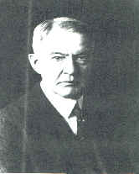
John J. Adams, Dean.

BIBLIOGRAPHY
April 1865, Jay Winik, HarperCollins Publishers 2001
The History of Muskingum County, Ohio, with Illustrations and Biographical Sketches of Prominent Men and Pioneers, J. F. Everhart and Company, 1882.
The History of Zanesville and Muskingum County, Ohio, J. Hope Sutor 1905.
Lincoln at Gettysburg, Garry Wills, Simon & Schuster 1992
Ohio State Penitentiary: Microfilm archive - Records = GR3628, GR03629, GR3630, GR3636
True American Newspaper
Zanesville and Muskingum County, Ohio, Thomas W. Lewis, Vols 1 and 2, S. J. Clarke Publishing Co, 1927.

Photos courtesy of the Ohio State University archives, the Ohio State University College of Law, the George Adams family album, and various sources public domain.
The 19th and 20th Century History of Prospect Place, The George Willison Adams Mansion, copyright 2019.

The G. W. Adams Education Center, Inc. Printed in the United States of America. No part of this book may be used or reproduced in any manner whatsoever without written permission except in the case of brief quotations embodied in critical articles and reviews.

For information address the G. W. Adams Center, Prospect Place, P O Box 196, Trinway, Ohio, 43842.

2019 Edition.

Official Website:
WWW.GWACENTER.ORG

